# Set up developer workplace

1. Install Eclipse IDE for LEAN DI developer(based on Eclipse Luna)

Follow the steps described in <https://wiki.wdf.sap.corp/wiki/display/LeanDI/Setup+Developer%27s+Workplace> to

* 1. Install Java JDK, if necessary
  2. Install the Eclipse IDE for LEAN DI developer, which already includes the maven-plug in and proxy settings
  3. Install maven
  4. Set up GIT and Gerrit <https://wiki.wdf.sap.corp/wiki/display/LeanDI/Getting+started+with+Git+and+Gerrit>

1. Install SAP Hana tools for Eclipse

<https://help.hana.ondemand.com/help/frameset.htm?9bd4dd19aef947b58eadf688ccc90de7.html>. Follow the steps “Installing Java Tools for Eclipse and SDK” with the following exceptions:

* 1. In step “Installing the SDK”, choose the SDK for Java Web (version 1.56.18.4)
  2. You can skip step “Installing the Eclipse IDE” as this is done in step 1
  3. In step “Installing SAP Development Tools for Eclipse”, use the URL for kepler version, i.e. <https://tools.hana.ondemand.com/kepler>. Remember that in step 1, Eclipse IDE for LEAN DI is using Luna version. But there is no corresponding Luna plug-in in SAP Hana tools yet.
  4. In step “Setting up the Runtime Environment”, choose the SDK from step (a).

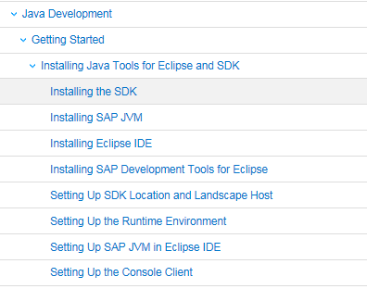

1. Copy the URL of the project “Translation Services” from the project portal <https://projectportal.wdf.sap.corp/projects/com.sap.translationservice>
2. Clone the ‘Translation Service’ from the GIT repository. (refer to recording from Martin)
3. Import existing maven project for TS into your local project explorer (refer to recording from Martin)
4. Deploy the application/bundle to SAP HANA Cloud Platform local runtime(refer to recording from Martin)
5. Install HANA studio to work with Hana tables/schema.